CSIT 321 – Final Year Project

Deep Learning based COVID-19 X-ray Image Classification

Group - FYP-23-S3-07

**User Manual**

|  |  |
| --- | --- |
| **Name** | **UOW ID** |
| Xie JiangFeng | 7358453 |
| Yin YingCheng | 7083440 |
| Zhang Boyu | 7896505 |
| Tan Wei Yang, Keith | 7366644 |
| Tan Jing Zhi | 7573261 |

**Supervisor:** Mr.Liaw Chun Huei

**Assessor :** Mr.Japit Sionggo

Contents

1. Introduction 2

1.1 Purpose 2

1.2 Target Audience 2

2. Overall Description 3

2.1 Use Cases Description 3

2.2 Website Activity Diagram 5

3. Website Product 6

3.1 Account Features 6

3.1.1 Login 6

3.1.2 Logout 6

3.1.3 Create Account 7

3.2 User: Doctor 8

3.2.1 Uploading image for analysis 8

3.2.2 Edit comment for previously submitted 10

3.2.2 Make report available/unavailable to the patient 11

3.3 User: Patient 12

3.3.1 View analysis report and comment from doctor 12

3.3.2 Save analysis report 12

# Introduction

## Purpose

The purpose of the user manual documentation for this website is to serve as a comprehensive guide for healthcare professionals, specifically doctors, and patients who will be interacting with the platform. It aims to provide clear and detailed instructions on how to effectively use the website's features and functionalities.

For doctors, the user manual will offer step-by-step guidance on the process of uploading X-ray images for diagnosis, interpreting the generated reports, and utilizing the platform to facilitate accurate COVID-19 diagnoses. It will also cover any additional tools or features available to them for a seamless experience.

For patients, the user manual will explain how to access and view the reports generated by the doctor. It will provide clear instructions on navigating the platform to ensure a user-friendly experience while maintaining privacy and security measures.

Overall, the user manual documentation will empower both doctors and patients to make optimal use of the website, ultimately contributing to the project's goal of enhancing healthcare outcomes in the face of the COVID-19 pandemic.

## Target Audience

The project is tailored for healthcare professionals, specifically doctors, who will upload X-ray images for diagnosis using the model. Patients will have access only to view the reports generated by the doctor. Medical related personnel such as healthcare professionals will benefit from the model more from the accuracy and the speed of detection, enabling them to make well-informed decisions and improve patient care.

# Overall Description

## 2.1 Use Cases Description

|  |  |  |
| --- | --- | --- |
| **User** | **Function** | **Description** |
| All users | Login | Users with correct login information can login and use the system. |
| Logout | Users can logout of the system with a click. |
| Create account | Users with not account and wish to use the system can create one, by providing some simple personal details. |
| Doctor | X-ray Image Upload | COVID-19 diagnosis. The uploaded images will be processed by the back-end model, to generate a analysis report . |
| Report Generation | The generated report will indicate the outcome of the analysis, providing information for efficient communication with the patient. |
| View Results | Doctor accesses results, which are generated based on the analysis of X-ray . The results will aid in making an accurate diagnosis for the patient. |
| Write Comments | Doctors are able to write comments or feedback on the report, improving the patient's understanding of the diagnosis. |
| Release Report | Doctor can releases the report to the patient. The patient will be able to access the report and comments on their condition. |
| Patient | Access Reports | Patient can check the status of their COVID-19 diagnosis. The status shows whether the report is still under analysis or completed. |
| View Report | The report contains the results of the analysis of the X-ray, informing the patient if the result is negative or positive |
| Read Doctor's Comments | Patients can read the comments provided by the doctor.  The comments may contain more insights on the diagnosis, helping the patient comprehend their medical condition more thoroughly. |
| Save | Patient can save the report for further analysis and evaluation in the future. |

## 2.2 Website Activity Diagram

Website structure for users doctor and patient.

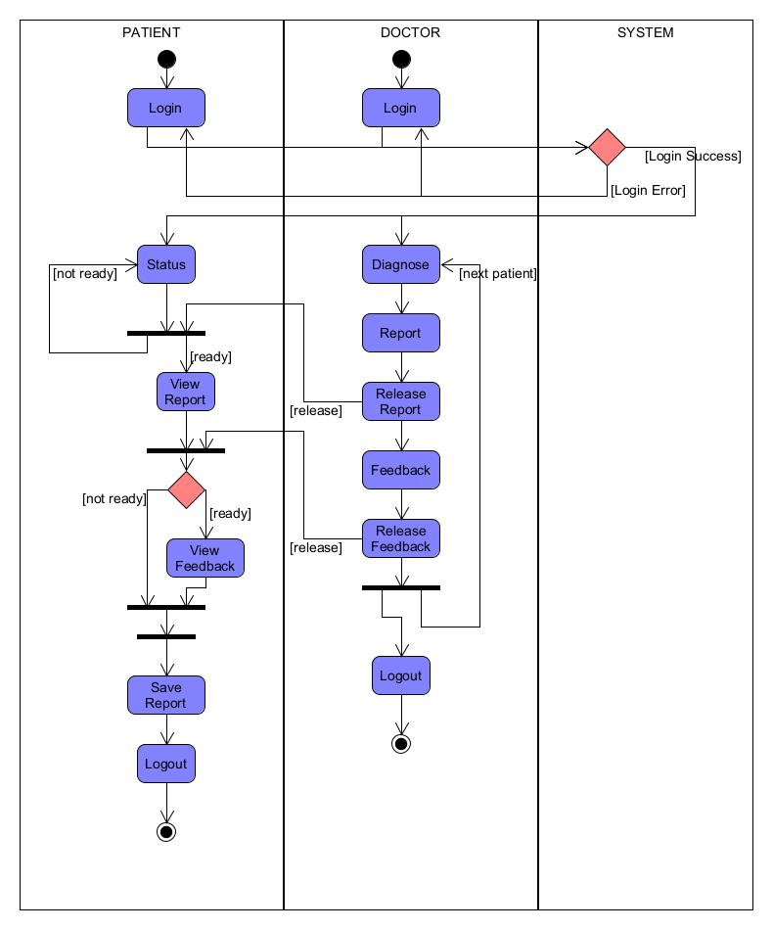

# Website Product

## 3.1 Account Features

### 3.1.1 Login

|  |  |
| --- | --- |
| **Instructions** | **Screenshot** |
| Fill in correct particulars and you will be brought to the corresponding main page. |  |

|  |  |
| --- | --- |
| **Possible errors** | **Screenshot** |
| If you fill in a wrong username/password |  |
| If one field is empty |  |

### 3.1.2 Logout

|  |  |
| --- | --- |
| **Doctor** | **Screenshot** |
| Go to the navigation bar and click the logout button. |  |

|  |  |
| --- | --- |
| **Patient** | **Screenshot** |
| Go to the navigation bar and click the logout button. |  |

|  |  |
| --- | --- |
| **Error** | **Screenshot** |
| This function has no possible error |  |

### 

### 3.1.3 Create Account

|  |  |
| --- | --- |
| **User** | **Screenshot** |
| Fill in all particulars and click “Create account button” |  |

|  |  |
| --- | --- |
| **Possible errors** | **Screenshot** |
| If any field is left empty |  |
| If password and confirm password field do not match |  |
| Account exists |  |

## 3.2 User: Doctor

### 3.2.1 Uploading image for analysis

|  |  |
| --- | --- |
| **instructions** | **Screenshot** |
| Go to the menu icon on the left of the navigation and click ‘Upload’ button. |  |
| Choose the image you want to upload from your local storage |  |
| Fill in patient information on the right box of the form |  |
| Press analyse image. Wait for “Create Report” button will appear, this process might take awhile.Click create report to view the report. |  |
| If you have any comments for the patient, you can type it in the comment box at the bottom of the report |  |
| If you are ready to create the report and record it in the database, press the “Submit” button. |  |

|  |  |
| --- | --- |
| **Possible errors** | **Screenshot** |
| If patient ID filed is left empty. |  |
| If no image is uploaded |  |
| If image uploaded is not a lung X-ray |  |

### 3.2.2 Edit comment for previously submitted

|  |  |
| --- | --- |
| **instructions** | **Screenshot** |
| From the home page, you can see all the submitted report. |  |
| Find the report you wish to edit, and click on the pen icon. |  |
| You are now in the report page, edit/add your comments. |  |
| Press “Submit” button |  |

|  |  |
| --- | --- |
| **Error** | **Screenshot** |
| No changes were made / Comment field I left empty |  |

### 3.2.2 Make report available/unavailable to the patient

|  |  |
| --- | --- |
| **instructions** | **Screenshot** |
| From the home page, you can see the status of the report. |  |
| Find the report you wish to release, and click on the check box |

|  |  |
| --- | --- |
| **Error** | **Screenshot** |
| This function has no possible error |  |

## 3.3 User: Patient

### 3.3.1 View analysis report and comment from doctor

|  |  |
| --- | --- |
| **instructions** | **Screenshot** |
| From the home page, you can see the status of your report. |  |
| Find the report you wish to view, and click the eye icon. |  |

|  |  |
| --- | --- |
| **Possible error** | **Screenshot** |
| Report is not available. The eye icon will have a strike across it. |  |

|  |  |  |
| --- | --- | --- |
| **instructions** |  | **Screenshot** |
| From the view report page, find the “Print and Safe” button and click on it |  |  |
| Click save and choose a destination from your local storage and click save again |  |  |

### 3.3.2 Save analysis report

|  |  |
| --- | --- |
| **Possible error** | **Screenshot** |
| This function has no error |  |